MOW the Grasse
Monitoring Our Water on the Grasse River
Field Handbook

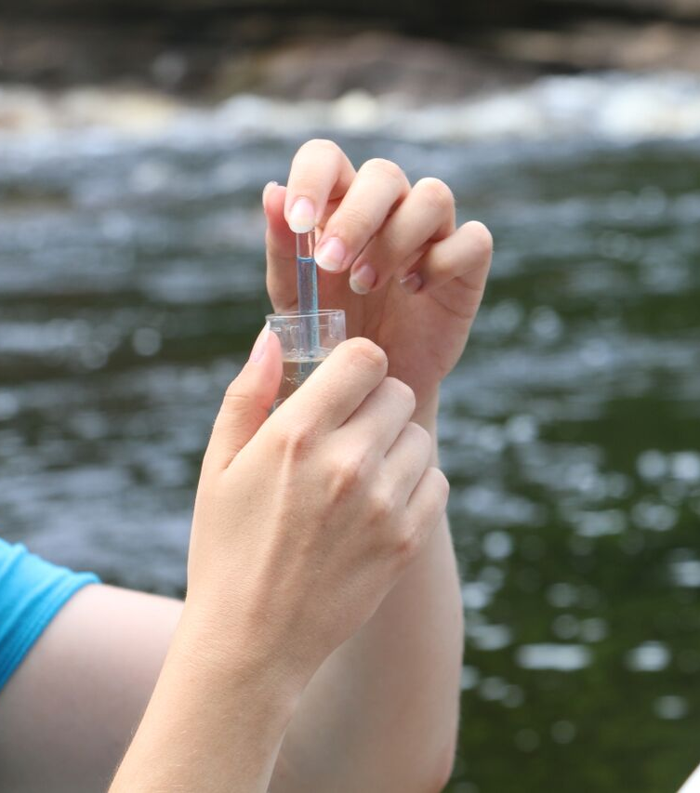
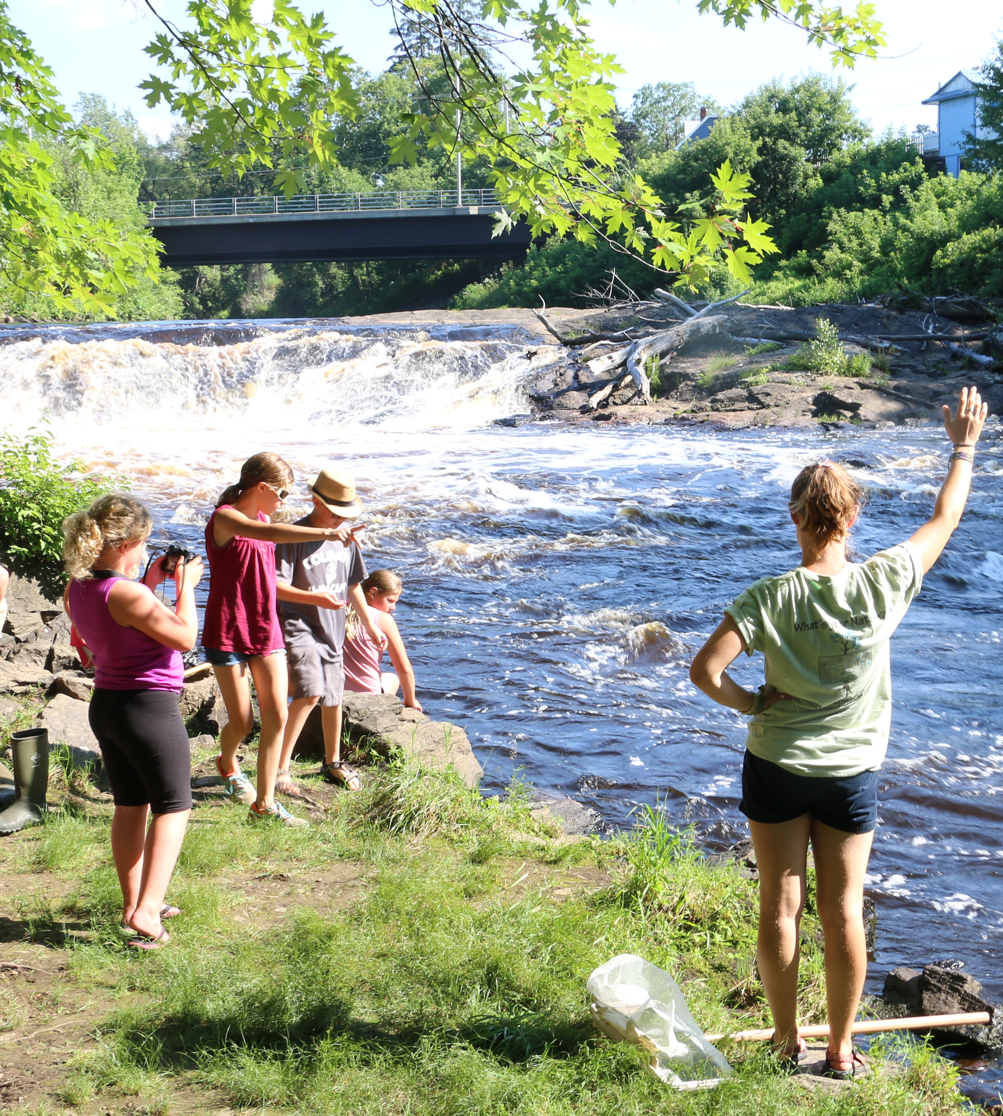

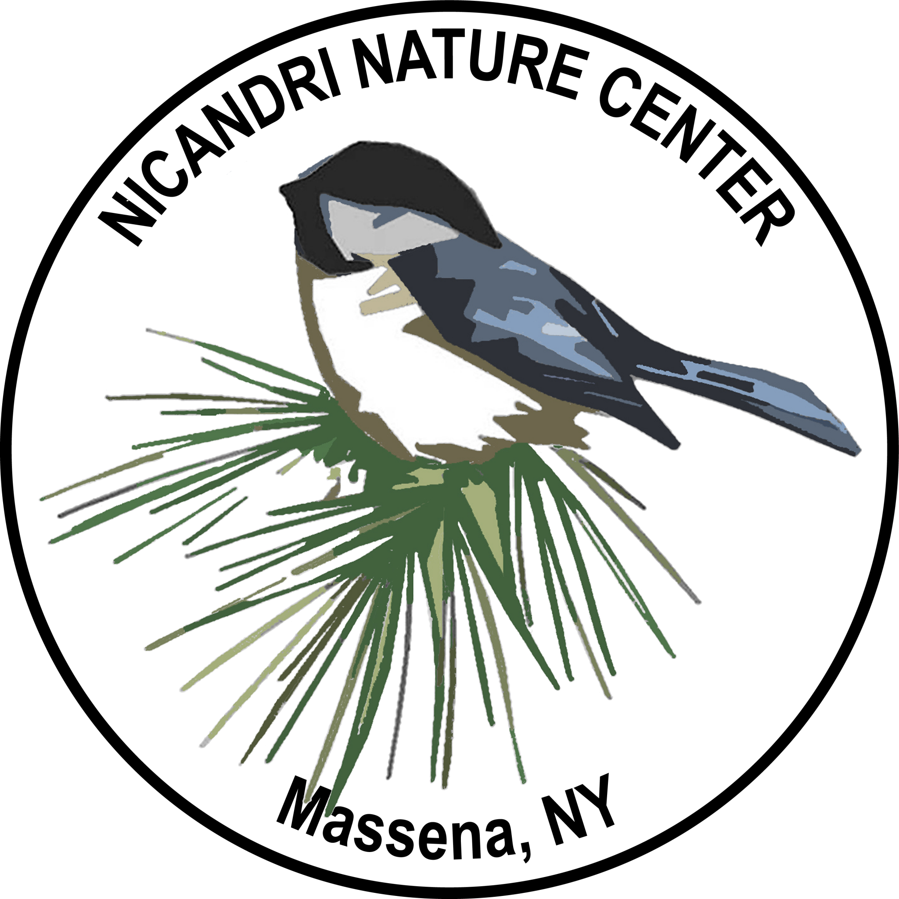

Contents

Welcome to Water Monitoring 3
About MOW the Grasse 4
Safety Notes 5
Water Monitoring Equipment 6
Water Sampling Outline 7
Location Details 8
Section 1: Physical Observations 9-13
Section 2: Chemical Observations 14-15
Section 3: Biological Observations 16-19
Macroinvertebrate Identification Guide 20-23
MOW Datasheet 24-25
Macroinvertbate Worksheet 26
Feedback Survey 27
Appendix I: WAVE 28
Appendix II: Instructions for Sampling Kits 29-31
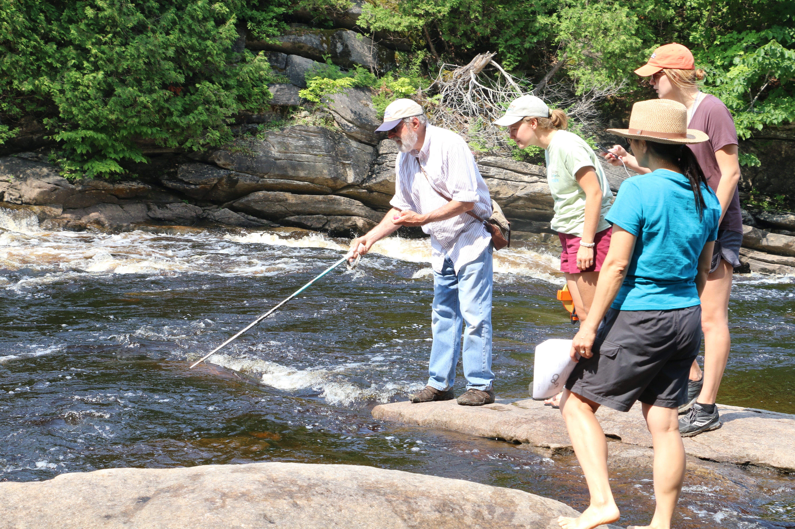
Welcome to Water Monitoring

Thank you for participating in MOW the Grasse as a water monitoring volunteer! This Field Handbook will take you through the step-by-step process of collecting physical, chemical, and biological data on water quality at your stream or river.

Please read all directions before sampling – your attention to detail is the quality of our data.
Contact us at Nature Up North at info@natureupnorth.org with any questions.

Volunteer Training
MOW the Grasse sampling must be completed alongside Nature Up North staff person or a MOW Coordinator from a Partnering Organization (see page 4) who has completed a MOW the Grasse Volunteer Training provided by Nature Up North. Please contact us for information about upcoming training opportunities.

Borrowing a MOW Kit Monitoring Equipment
Nature Up North lends water sampling kits to MOW Coordinators and other trained volunteers such as local High School Science Teachers. This handbook contains a complete list of required materials.

Submitting Data
We are currently working on building a data submission portal on natureupnorth.org.
For the time being, please submit your data to Nature Up North at info@natureupnorth.org or via mail at Nature Up North, Biology Dept. St. Lawrence University, 23 Romoda Drive, Canton NY, 13617.

Thank you for your contributions, and happy monitoring!

The Nature Up North Team, June 2018

Emlyn Crocker, Project Manager
Erika Barthelmess, Director
Elizabeth Kamb (Water Monitoring Intern, Summer 2017)
About MOW the Grasse
Made possible by grants from the St. Lawrence River Research and Education Fund and the Walker Foundation, MOW the Grasse aims to build a community-based water quality-monitoring program on the Grasse River. In partnership with Grasse River Heritage and the St. Lawrence Land Trust, Nature Up North began piloting the project in the summer of 2017 with volunteer trainings. Partner organization have each adopted a location along the river where they will conduct regular water sampling and Nature Up North will curate and shares the data freely to the community on natureupnorth.org.
Nature Up North began volunteer trainings with partner organizations in summer 2017, and the project launched spring 2018. Science teachers at North Country schools use MOW the Grasse materials and protocol to conduct stream studies with students.

MOW the Grasse Partners & Monitoring Sites
- Nature Up North – Downerville State Forest, Russell NY
- Grasse River Heritage Falls Island – Heritage Park, Canton NY
- St. Lawrence Land Trust – Harts Falls, Hermon NY
- Nicandri Nature Center – Downtown Massena (Fire Dept.), Massena NY

Water Assessments by Volunteer Evaluators (WAVE)

WAVE is citizen-based water quality assessment developed by the NYS Department of Environmental Conservation (NYSDEC). The purpose of WAVE is to enable citizen scientists to collect biological data for assessment of water quality on wadeable streams in NY State (see Appendix I, page 29).

What about Other Waterways in SLC?
We are currently accepting data collected on the Grasse, Raquette, Oswegatchie, St. Lawrence, St. Regis, and Little Rivers – please indicate your water body when submitting data.

More about Nature Up North
Nature Up North is a community-based organization based at St. Lawrence University whose mission is to foster a deeper sense of appreciation for, and connection to, the North Country environment and in doing so to create a bioregionally literate community that is committed to protecting the wild things and wild places that define this place we call home. For more information, visit www.natureupnorth.org or contact us at info@natureupnorth.org.
Safety Notes

Water Monitoring Safety
Safety is an important first step in every volunteer citizen science program. Please read the following safety precautions before you start monitoring activities.

- Bring a friend! Please monitor with at least one other person. Always let someone else know where you are and when you intend to return.
- Avoid wading in high or fast moving water. Do not enter a stream/river deeper than your knees. Please avoid monitoring during storm weather.
- Be cautious of your footing when walking in water. We recommend boots or sneakers in good condition that you don’t mind getting wet. Close-toed shoes are always advised.
- Bring a first aid kit and cell phone.
- Be aware of animals and plants in your area. Watch for ticks, mosquitoes, and hornets, and ask in advance if anyone in the group has particular allergies. Be wary of walking through poison ivy, common to disturbed areas.

Handling Chemicals
Please read the directions and safety tips provided with each sampling kit. The reagents provided in the CHEMetrics kits are mild skin and eye irritants.

- Avoid contact. Please wear latex gloves when working with chemicals, and avoid contact with skin, eyes, nose, or mouth.
- Follow safe procedures for chemical clean-up, disposal, and first aid. Use sealed plastic containers to store chemical waste in the field. If a volunteer accidentally consumes chemical reagents, contact your local poison control office. For assistance disposing of chemical, contact Nature Up North staff.

Prevent the Spread of Aquatic Invasive Species (AIS)

As MOW volunteers, it is your responsibility to help us prevent the spread of aquatic invasive species in Upstate New York waterways. Please remove all mud and plants from sampling equipment and drain all water before transporting.

Equipment decontamination is necessary following each sampling location if working from downstream to upstream or sampling at different water bodies in the same day. For simple decontamination, rinse equipment well with 104º F + water. Sampling gear should dry for 5 days between sampling of different water bodies to allow unseen hitchhikers to die.

Water Monitoring Equipment

Required—

☐ Air temperature probe
☐ Water temperature probe
☐ Floating object
-orange/ tennis ball/stick
☐ Meter stick/tape
☐ Timer
☐ Calculator
☐ Water collection bottles
☐ Distilled or deionized water
☐ CHEMetrics Dissolved Oxygen Kit
☐ LaMotte Precision pH 3.0-10.5 Kit
☐ CHEMetrics Phosphate Kit
☐ LaMotte Nitrate Nitrogen Low Range
Comparator Kit
☐ Latex gloves
☐ Hach Kit (or other Turbidity probe)
☐ Coliscan Easygel Water Testing kit
☐ Sterile water collection bottles
☐ “D” shaped rectangular sampling net(s)
☐ Large clear plastic bin/tupperware
☐ Forceps/tweezers
☐ Magnifying glasses
☐ Ice cube trays
☐ Macroinvertebrate ID Guide
☐ MOW Field Guide

Optional—

☐ Long tape measure/yard stick
☐ 5 Gallon Buckets
☐ Threaded lid modifier (for buckets)
☐ Buckets with mesh bottom
☐ Spray bottles
☐ Plastic spoons
☐ Paint brushes
☐ Droppers
☐ Magnifying box
☐ Field Guide to Aquatic Macroinvertebrates

*all required sampling materials can be loaned free of charge from Nature Up North. Please give 2 weeks + advance notice.

Water Sampling Outline

Location Details
- Water Body, Site name, Date, Time, Participants Names, Latitude/Longitude and Sampling Objective(s)
Section 1: Physical Observations
- Weather
- Air Temperature
- Water Temperature
- Water Velocity - optional
- Turbidity - optional
- Dissolved Oxygen
- WAVE physical observations
Section 2: Chemical Observations
- pH kit
- Phosphate
- Nitrate

Section 3: Biological Observations
- Coliform and E. coli bacteria - incubation required
- Macroinvertebrate Sampling
  - Collection with Four-Transect kick/net method (WAVE)
  - Sorting/identification (Macroinvertebrate Guide)
  - Percent per Tolerance Groups (Macroinvertebrate Worksheet)
  - Sample vial for WAVE (NYDEC)

Location Details

Let’s start monitoring! Before beginning to collect data for any of the three sections, please record the following information on your datasheet.

Water Body – Which river are you sampling at today?
Options: Grasse, St. Regis, Raquette, Oswegatchie, Little River, Other

Site Name – Where on the river is your sampling site? Give your site a name!

Participants – Include full names of everyone present

Contact email – Include email address for at least one participant

Date – Sampling date

Time – Window during which samples are collected. Please record time using the 24-hour clock, or “military time”.
Example: 15:00 - 16:30 (3:00pm – 4:30pm)

Objectives – What are your objectives? Which section(s) will you complete?

Section 1: Physical Conditions

Physical environmental conditions of an aquatic ecosystem not only influence what species are present in a river, but also their distribution, abundance and activity. Measuring stream flow, examining water and habitat quality and interpreting watershed characteristics will help explain the chemical and biological data we collect.

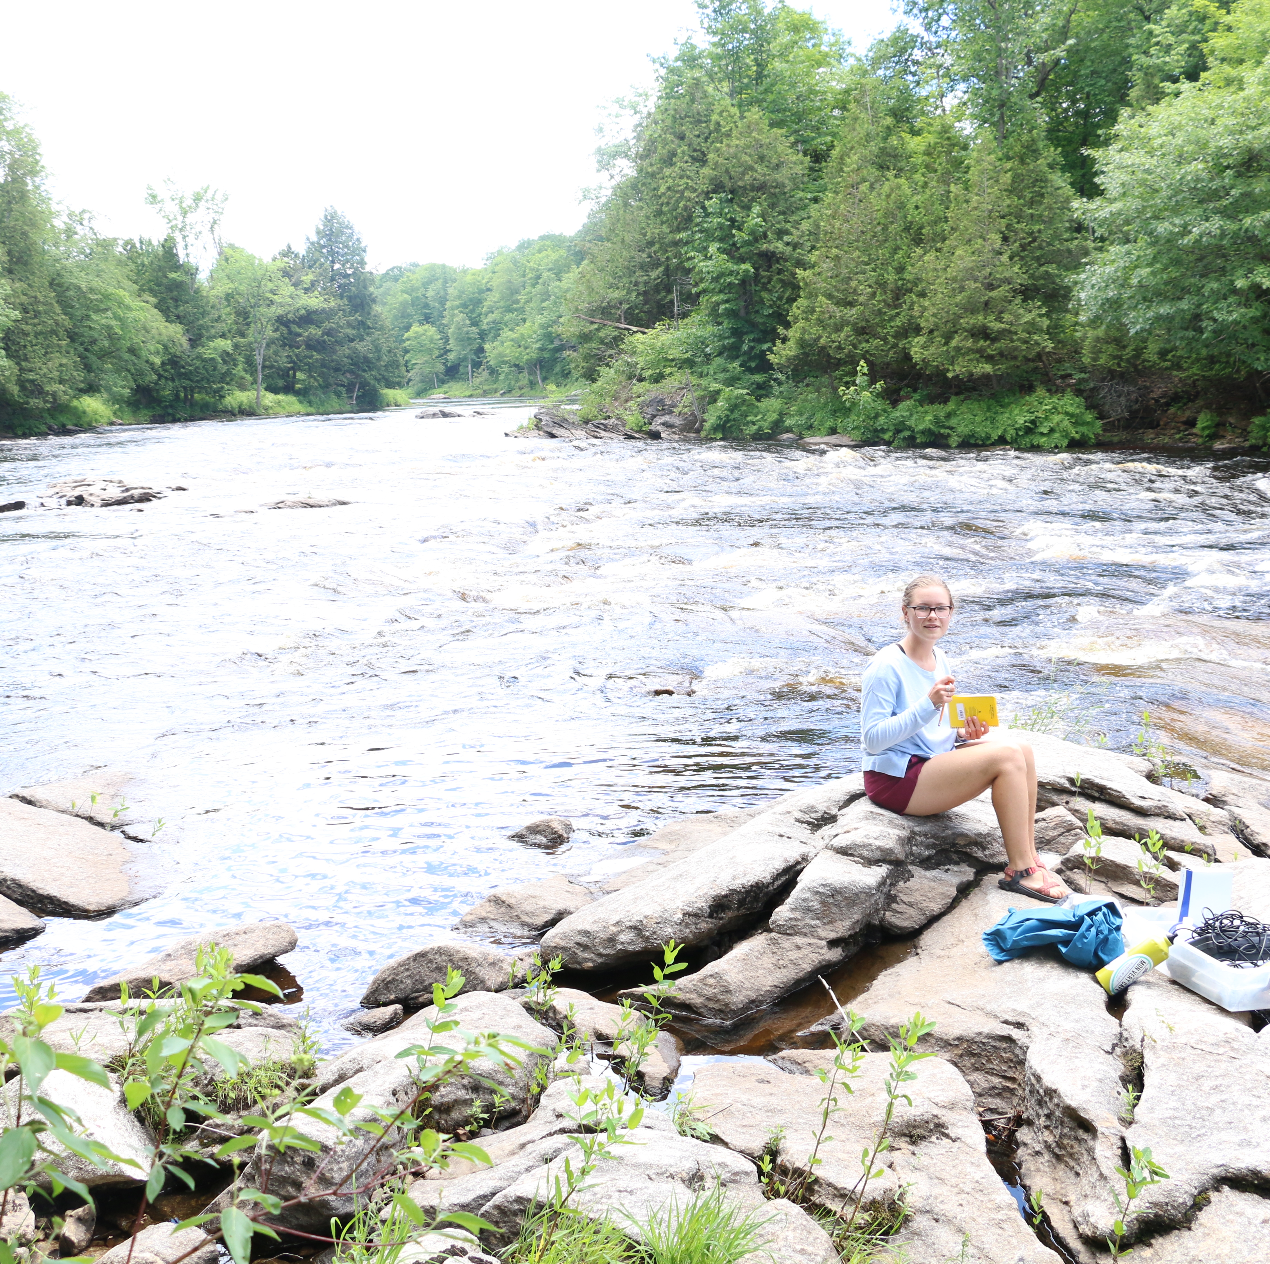
Materials
☐ Air temperature probe
☐ Water temperature probe
☐ Floating object (orange/ tennis ball/stick)
☐ Meter stick/tape
☐ Timer
☐ Calculator
☐ Hach Kit (for Turbitidy)
☐ Water collection bottle
☐ Distilled or deionized water
☐ Chemetrics dissolved oxygen kit

Nature Up North 2017 MOW intern Liz Sampling at Hart’s Falls, July 2017. Photo Molly McMasters.

Weather –
Materials: Datasheet, pencil People: All

Recording the weather every time you sample is essential. Record current weather conditions as well as notable weather during the days preceding data collection that might have impacted current conditions. For example, heavy rain events, wind or a particularly cold or hot day.

Air Temp –
Materials: water temp probe People: 1-2

Air temperature influences water temperature because air mixes into surface water through diffusion and movement—think of “white water” or rapids!

  - Hold the air temperature probe away from your body and allow it to stabilize.
  - Record the temperature reading in degrees Celsius.
Note: To get an accurate reading, remember to hold to probe by the end without the sensor and away from your body heat.

Use these equations to convert between degrees Celsius and Fahrenheit:

$C =\frac{F – 32}{1.8}$ $F = (C x 1.8) + 3$

Water Temp –
Materials: water temp probe People: 1-2

Water temperature effects the chemical and biological conditions in the water body. For example, colder water has higher O₂ levels, which is important for sustaining life.

- Place the thermometer below the water’s surface. If possible, obtain the temperature reading in the main streamflow.
- Swirling gently, hold the thermometer in the water for approximately 1 minute or until the reading stabilizes.
- Record the water temperature in °C or °F (conversions on previous page).

Note: To get an accurate reading, remember to make sure that the probe sensor is not obstructed. For example, placing your water temperature probe near a cold spring will decrease the water temperature reported by the probe.

Water Velocity – OPTIONAL

Materials: floating object, meter stick, timer, calculator People: 2-4

Water Velocity, the speed at which water travels through a river, impacts stream flow (also called discharge) and is central to building its character. For example, faster moving water is able to carry more sediment, creating a river with less sediment buildup.

- Measure 10 meters along the river and mark with flags, nets, natural markers or participants.
- Hold a floating object (ie orange, tennis ball, stick) over the running water at the upstream marker and have someone ready to start a timer. Drop the floating object into the water and start the timer at the same time.
- Stop the timer when another participant downstream signals that the floating object travelled the full distance along the river. Start and stop the timer as accurately as possible. Record the float time in seconds.
- Float the object down the stream 4 times and record the time for each trial.
- Follow directions below for calculating velocity. (example: 1.5 s/m means that it takes 1.5 seconds for a molecule of water to travel one meter down the river).

Calculating Velocity

$$Velocity (m/s)= \frac{Mean Speed (seconds)}{Distance (meters)}$$

Trial 1: (________s) Trial 2: ( ________ s) Trial 3: ( ________s) Trial 4: (________ s)

Sum of Trials 1-4 ( _____________) / # of Trials (4) = ______________ s (Mean Speed)

Mean Speed (____________s) / Distance (___________m) = Velocity (______________m/s)

Turbidity –
Materials: Hach Kit or Turbidity meter, water collection bottle People: 1-2
Distilled or deionized water

Turbidity, a measure of the volume of particles suspended in the water, increases with heavy rainfall/runoff and nutrient content. Often referred to as “water clarity”, turbidity can affect the way aquatic organisms interact with their environment and each other, and impact primary productivity, predation and tropic dynamics.

Materials: Hach Kit, water collection bottle, distilled or deionized water
People: 1-2

Directions for sampling Turbidity using the Hach Kit
  - Collect a water sample with a plastic collection bottle.
  - Turn the Hach Kit display on and enter the stored program number for the Absorptometric Method to measure turbidity. Press PRGM, then 95, then ENTER. The display will show FAU (the unit of measurement) and the ZERO icon. FAU or Formazin Attenuation Units measure the decrease in transmitted light through the sample at an angle of 180 degrees to the incident light.
  - Fill a sample cell with 10 mL of deionized water and label it. This is the blank you will use to zero the measurement. Wipe the surface of the cell with a soft cloth.
  - Place the blank into the cell holder. Tightly cover the sample cell with the instrument cap.
  - Press ZERO. The cursor will move to the right, then the display will show: 0 FAU.
  - Shake the collection bottle well to mix the sample. Fill another sample cell with 10 mL of sample and label. Wipe the surface of the cell with a soft cloth.
  - Place the sample cell into the cell holder. Tightly cover the sample cell with the instrument cap.
  - Press READ. The cursor will move to the right, then the result in FAU will be displayed.

Dissolved Oxygen –

Materials: CHEMets® Dissolved Oxygen Kit People: 2-4

Dissolved oxygen (DO) levels in freshwater can be an indication of how polluted the water is and how well the water can support aquatic plant and animal life. Generally, a higher dissolved oxygen level indicates better water quality.

Follow sampling instructions in CHEMets® Dissolved Oxygen Kit

Pro tip: Don’t shake your sample! Dip the bottle slowly to collect an accurate sample.

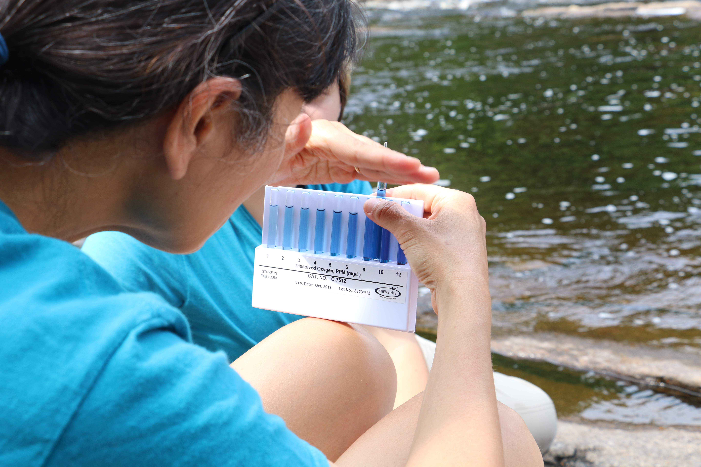
A volunteer tests dissolved oxygen levels at Hart’s Falls during a volunteer training, summer 2017. Photo: Maya Williams.

Section 2: Chemical Observations

Water chemistry is different in every waterbody, and determines the specific community of organisms that call it home, as well as their abundance, distribution and behavior. In this section, you will measure pH, phosphorus and nitrogen levels.

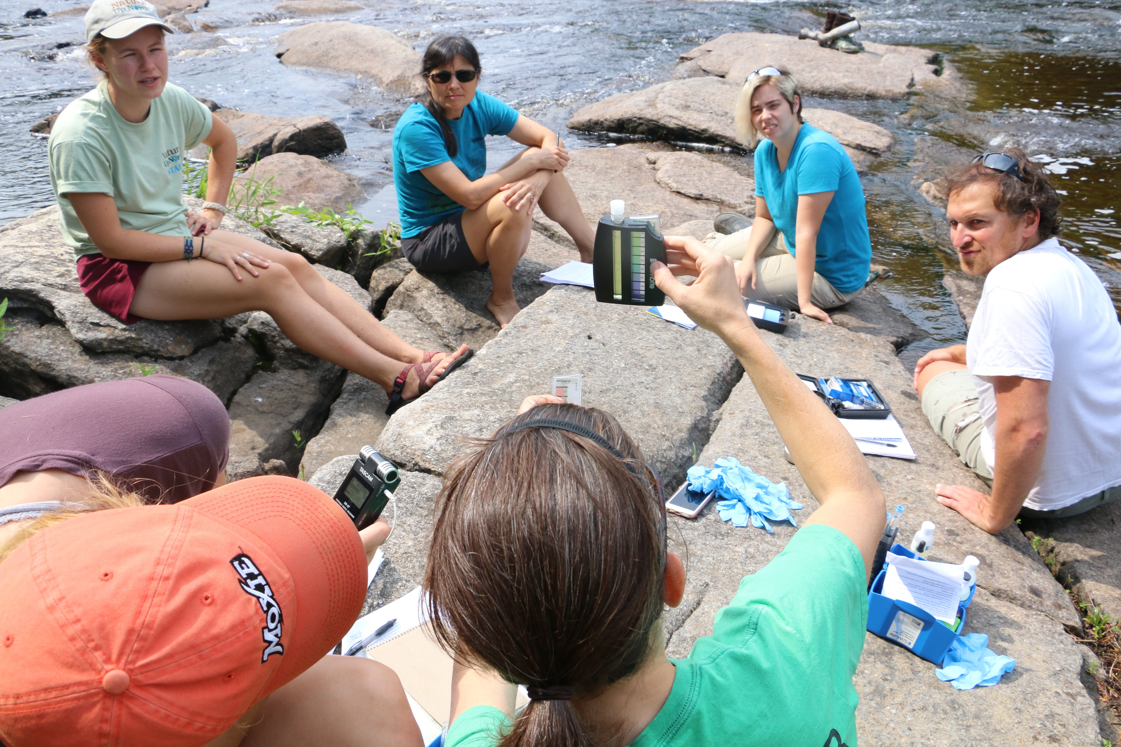
Materials
☐ LaMotte® Precision pH 3.0-10.5 Kit
☐ CHEMets® Phosphate Kit
☐ LaMotte® Nitrate Nitrogen Low Range
Comparator Kit
☐ Chemical waste container
☐ Nitrogen waste container
☐ Sharps container
☐ Latex gloves

Volunteers from the St. Lawrence Land Trust examine the results of a pH test during a MOW volunteer training, summer 2017. Photo: Maya Williams

pH –
Materials: LaMotte® Precision pH 3.0-10.5 Kit People: 2-4

Aquatic organisms are sensitive to acidity and alkalinity, especially during reproduction. Many natural factors affect pH including changes in temperature, biological processes like photosynthesis and respiration, nutrient and chemical runoff, and geology. The pH scale ranges from 0 (most acidic) to 14 (most alkaline), with 7 being neutral.

Follow sampling instructions in LaMotte® Precision pH 3.0-10.5 Kit. Please wear gloves while sampling, and be sure to dispose of waste in your chemical waste container. When selecting your color match, we recommend asking everyone in the group to take a turn looking. Can’t decide—try a vote! Record on the datasheet.

Phosphorus –

Materials: CHEMetrics Phosphate Kit, Latex gloves People: 2-4
Chemical waste container

Phosphorus (P), a nutrient found in organic material and many man-made products such as fertilizers, is essential for plant growth. Too much phosphorus in freshwater can lead to harmful algal blooms. When the algae die, the decomposition can deplete the ecosystem of oxygen.

Follow sampling instructions in CHEMetrics Phosphate Kit. Please wear gloves while sampling, and be sure to dispose of waste in your chemical waste container. Record your result on the datasheet.

Nitrogen –

Materials: LaMotte® Nitrate Nitrogen Low Range Comparator People: 2-4
Latex gloves
Sharps container
Nitrogen waste container

An organic nutrient, nitrogen (N) is both naturally occurring and introduced via fertilizers. Nitrogen is a limiting nutrient for many plants, and impacts nutrient loading and trophic dynamics.

Follow sampling instructions in LaMotte® Nitrate Nitrogen Low Range Comparator. Please wear gloves while sampling, and be sure to dispose of waste in your designated Nitrogen waste container. Record your result on the datasheet when the test is complete.

Section 3: Biological Observations

By collecting information about biological activity present in freshwater, it’s possible to make conclusions about river health even in the absence of physical and chemical data. Living organisms such as bacteria and macroinvertebrates act as indicators for the certain environmental conditions in which they can survive and thrive.
In this section, you will measure E. coli, coliform bacteria and macroinvertebrate populations and make an assessment of the water quality of your stream or river.

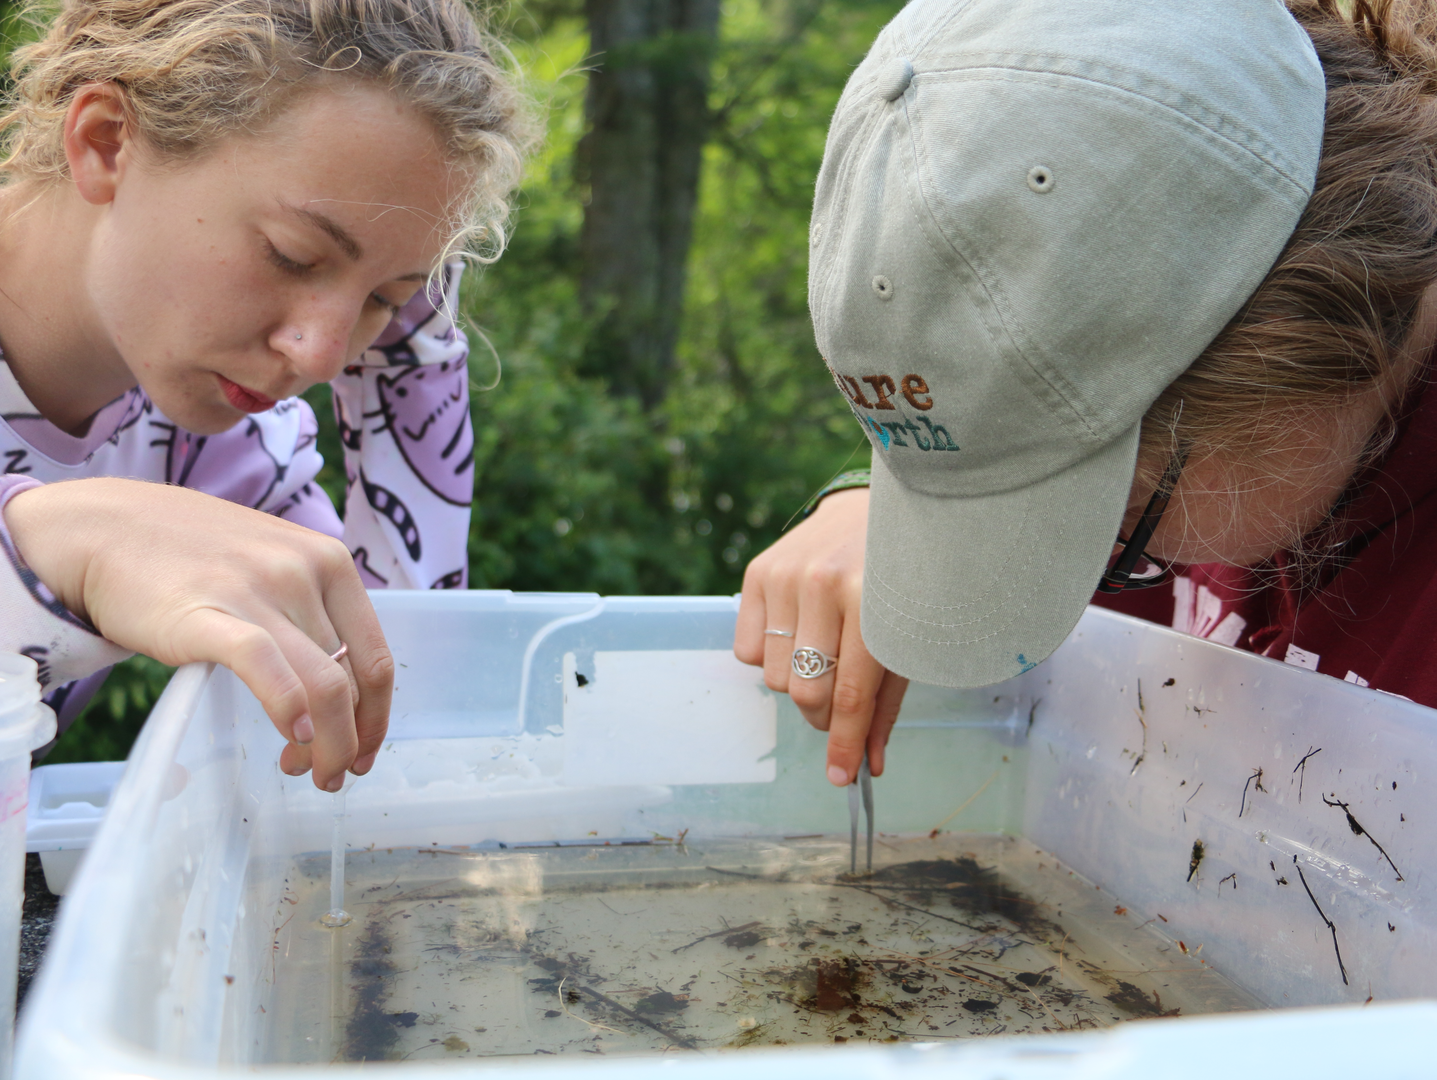
Nature Up North 2017 interns Molly and Liz sort macroinvertebrate samples collected at Brandy Brook. Photo: Maya Williams.
Materials
☐ Coliscan Easygel® Water Testing kit
☐ Sterile water collection bottles
☐ D shaped sampling net
☐ Large clear plastic bin/Tupperware
☐ Forceps/tweezers
☐ Plastic spoon
☐ Plastic dropper
☐ Magnifying glasses
☐ Ice cube trays for sorting
☐ Macroinvertebrate ID guide

E. coli and Coliform Bacteria –

Materials: Coliscan Easygel® Water Testing kit People: 1-2
Sterile water collection bottles

Sampling for indicator organisms like E. coli and coliform bacteria is a great way to assess potential to contract a disease from fecal contamination in river waters. Testing for coliform bacteria is a reasonable indication for whether other pathogenic bacteria are present because they come from the same sources.

Follow instructions in Coliscan Easygel® Water Testing kit. Use your lab’s incubator, or bring to St. Lawrence University for incubation. Count colonies and record result.

Macroinvertebrate Sampling –

Materials: D net, large clear plastic bin People: All
forceps/tweezers, plastic spoon, plastic dropper,
magnifying glasses, ice cube trays, Macroinvertebrate ID guide

Aquatic macroinvertebrates are small organisms that live in streams and rivers (“macro” meaning small but visible with the naked eye, and “invertebrate” meaning without a backbone). Some macroinvertebrates are very sensitive to their environment, while others are not. Sampling the aquatic macroinvertebrates inhabiting a river can indicate the overall health of the aquatic ecosystem.

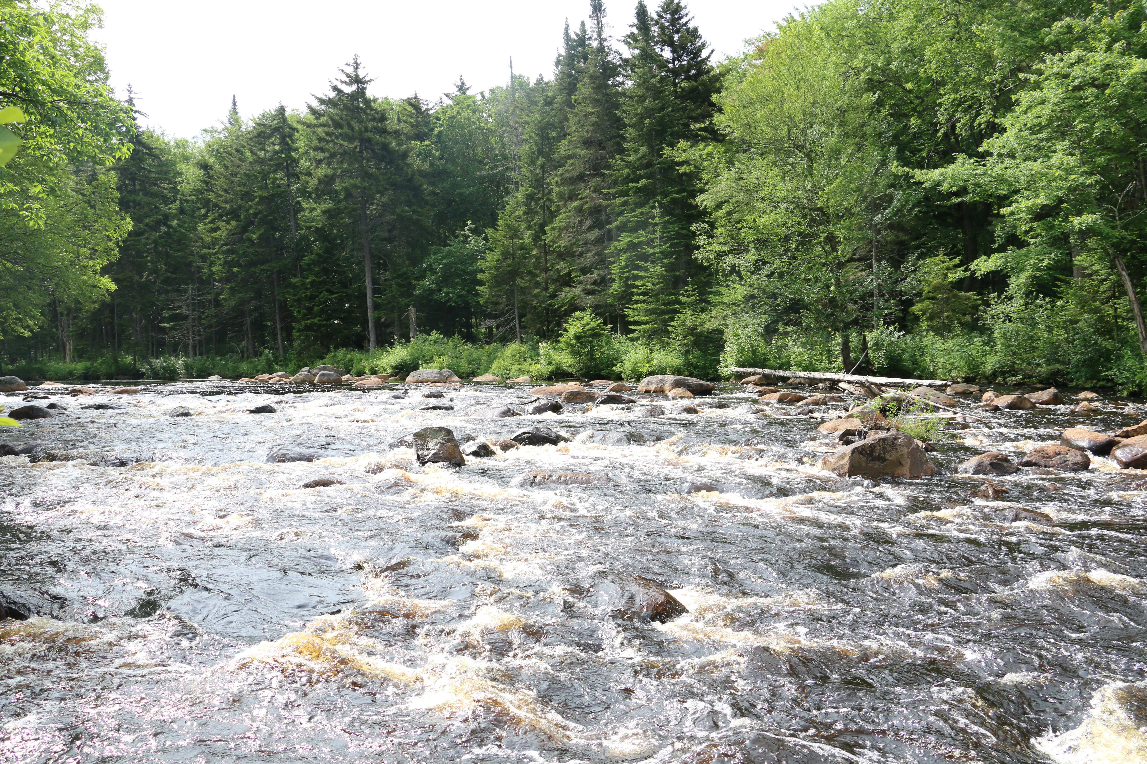
Example of riffles at a sampling site, Brandy Brook, NY. Photo: Maya Williams

- Locate the best riffle at the sample site – where the water is bubbling over rocks and maximum oxygen is being forced into the water.

- Visualize and discuss a five meter transect to sample, or use meter tape to display. In pairs, select a sample transect in the best possible macroinvertebrate habitat.

- Facing downstream, place the D net firmly on the stream bottom with the net opening facing upstream.

- Have one partner holds the net, while the other partner picks up rocks in front of the net and brushes them off on all sides directly upstream of the net, removing sediments and organisms. Throw rock aside and repeat several times.

- After brushing off rocks, have one partner kick side to side in front of the net, moving rocks and sediments in front of opening to disturb the stream bottom. Dislodged macroinvertebrates will be washed into the net by the stream current.

- Gradually move downstream along your transect repeating steps 4-5. Kick a total of 5 meters of substrate in five minutes, rubbing off all rocks thoroughly and disturbing the river bottom to a depth of 6 cm if possible.

- Dump contents of the net into a clear plastic bin (or a bucket if sorting the sample later). Rinse the net to make sure everything is drained and add 1-2 inches of additional water to the bin.

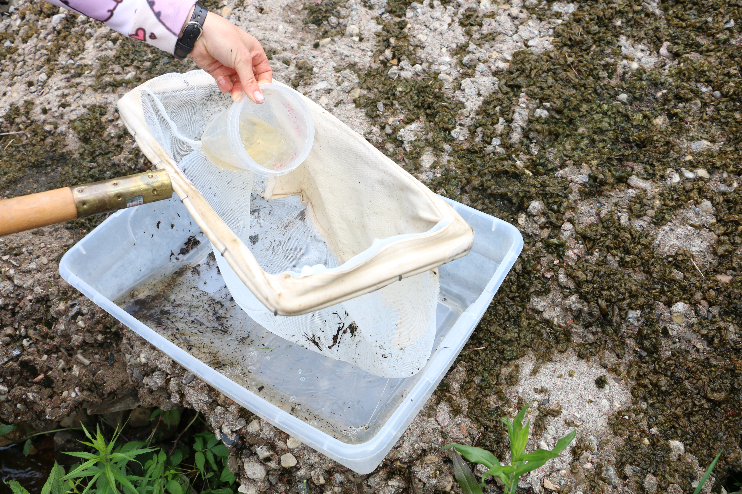
Volunteers transfer contents of a net into a plastic bin at Brandy Brook, NY. Photo: Maya Williams
- Remove large debris like sticks, rocks and leaves from the sample. Rinse off in bin to ensure there are not organisms hiding in the debris before discarding.

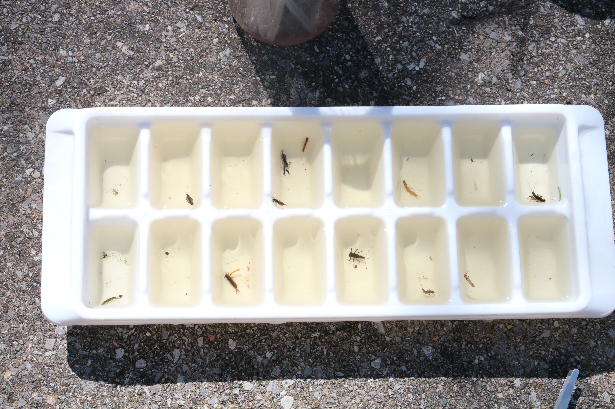
Sorting macroinvertebrates in ice cube tray. Photo: Nature Up North 2017

- Fill the ice cube trays with stream water and place on flat surface.

- Begin sorting your sample! Sort organisms into the ice cube tray by placing identical individuals together in the same well. Try using droppers, tweezers and paint brushes to see which works best for you.

Pro Tip: It might be easiest to start with the largest, most obvious organisms and work your way toward the smaller, more elusive ones!

- After sorting all the macroinvertebrates in your sample, use the Macroinvertebrate Identification Guide to begin identifying and counting the different species. Tally your results and calculate the percentage for each tolerance group on the Macroinvertebrate Worksheet.

Macroinvertebrate Identification Guide
Group 1 - Sensitive: Very sensitive to pollution, living in good-quality water

-Stonefly nymph -Riffle beetle -Gilled snail
-Mayfly nymph -Dobsonfly larvae -Water penny larvae
-Non-netspinning caddisfly larvae

Water Penny Larvae
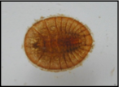
Order: Coleoptera
- Wing pads absent
- Flattened disc-like body
- 6 legs under dorsal plate
Photo: Meyers, 2009

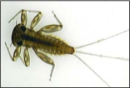
Mayfly Nymph—
Order Ephemeroptera
- 6 legs
- 3 tails
- Gills on abdomen
- Single claw on end of legs
Photo: Clapp, 2006

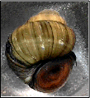
Gilled Snail—
Class Gastropoda
- Vary in size
- Presence of operculum
(Characteristic of gilled snail)
- Opening is on right hand side
Photo: Lake County, Ohio, 2009

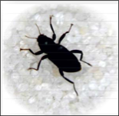
Riffle Beetle—
- Order Coleoptera
- Oval elongate body
- 6 legs
Photo: Peckarsky, 1990

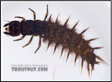
Dobsonfly Larvae (Hellgrammite)
Order: Megaloptera
- 6 legs
- Poorly developed eyes
- 2 anal prolegs with hooks
- Well developed chewing parts
- 8 abdominal segments, each with filament
Photo: Neuswanger, 2009

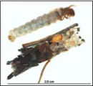
Non-Netspinning Caddisfly Larvae—Order Trichoptera
- 6 legs
- 2 anal hooks
- Worm-like body
- Often build cases
Photo: University of Wisconsin, Extention, 2007

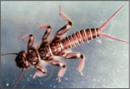
Stonefly Nymph
Order Plecoptera
- 6 legs
- Usually 2 tails
- Gills on thorax
- 2 claws on end of each leg
Photo: Meyers, 2009

Macroinvertebrate Identification Guide Group 2 – Moderately Sensitive: Survive in water quality that is good to fair
-Beetle larvae -Dragonfly nymph -Damselfly nymph
-Clam -Cranefly Larvae -Sowbug
-Crayfish -Scud -Fishfly larvae
-Alderfly Larva -Net-spinning caddisfly

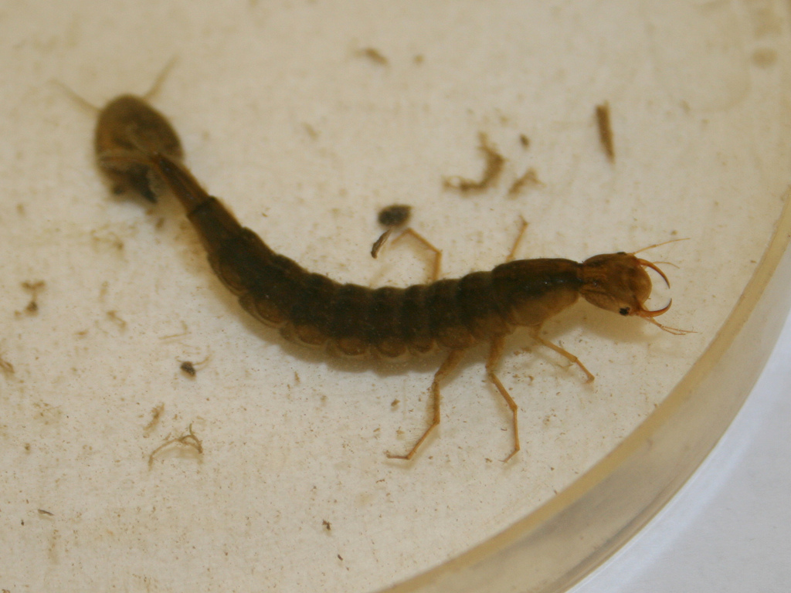
Beetle Larvae
Order Coleoptera
- Legs usually present
- No terminal prolegs
- Abdomen composed of 8-10 segments
Photo: Flickr Creative Commons user born1945

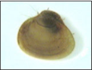
Clam
Class Pelecypoda
- Two piece shell
- Commonly oval
- Approx 2-250 mm
Photo: Clapp, 2006

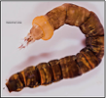
Crane Fly Larva
Order Diptera
- No wing pads
- Worm-like body
- 8-10 abdominal segments Photo: Neuswanger, 2009

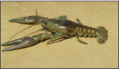
Crayfish
Order Decapoda
- 2 large claws
- 8 legs
- 2 long antennae
Photo: Wisconsin Department of Natural
Resources, 2008

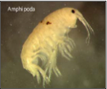
Scud
Order Amphipoda
- Laterally flattened
- Swims sideways
- 7 pairs of legs
- Resembles shrimp
Photo: California Department of Fish and
Game, 2009

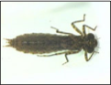
Dragonfly Nymph
Order Odonata
- Large labium (lower lip)
- No gills along the body
- 3 wedge-shaped “tails”
- Moderately developed eyes
Photo: Neuswanger, 2009

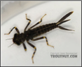
Damselfly Nymph
Order Odonata
- Large labium (lower lip)
- No gills along the body
- 3 feather-like “tails”
- Moderately developed eyes
Photo: Neuswanger, 2009

Macroinvertebrate ID Guide
Group 2 – Moderately Sensitive, cont.

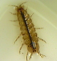
Sowbug
- Order Isopoda
- 7 pairs of legs and 2 antennae
- Dorsally flattened
Photo: Clapp, 2006

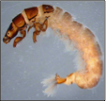
Net-spinning Caddisfly larva
Order Trichoptera
- 3 pairs of legs
- 1-3 sclerotized (hardened)
thoracic segments
- Branched gills may be
present on ventral side of abdomen
- Anal hooks may also have tufts of longer hair
Photo: University of Minnesota, 2003

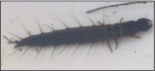
Fishfly Larva
Order Megaloptera
-No gill tufts
underneath abdomen
-Resembles a small hellgrammite
Photo: North Caroline Museum of Natural
Sciences, 2005

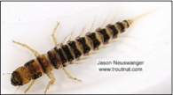
Alderfly Larva
Order Megaloptera
- 7 pairs of 4-5
segmented lateral
filaments on abdomen
- Single unbranched terminal filament
Photo: Neuswanger, 2009

Macroinvertebrate Identification Guide Group 3 – Tolerant: Survive in good, fair, and poor water quality
-Aquatic worm Blackfly larva Midgefly larva
-Leech -Other snails

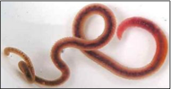
Aquatic Worm
Class Oligochaeta
- 7-500 body segments
- Elongate cylindrical
worms usually 1- 30 mm in length
Photo: Texas Flyfishers, 2006

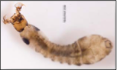
Blackfly Larva
Order Diptera
- Cylindrical body with one end wider
- Head with fan-like mouth brushes

Midge Fly Larva—Order Diptera
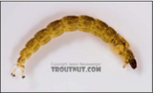
- May have prolegs on thorax
- Terminal segment of abdomen may have processes on it
- Worm-like body
- No wing pads
- May resemble caddisfly
Photo: Neuswanger, 2009

Leech
Order Hirudinea
- Dorsoventrally flattened
- Anterior and posterior ventral suckers

Other Snails
Class Gastropoda
- Non-gill breathing snails
- Do not have an operculum
- Opening is usually on left side
MOW the Grasse Datasheet – page 1

Location details

Water Body: _______________________ Date: _______________________

Site Name: _______________________ Latitude: _______________________

Participants: _______________________ Longitude: _______________________

___________________________________ Time: _______________________

Group/Organization: ___________________________________________________________

Sampling Objectives: ___________________________________________________________

Section 1: Physical Observation

Weather: __________________________________________________________________

______________________________________________________________________________
Measuring Velocity

$$\frac{Average Speed (seconds)}{Distance (meters)}=Velocity (m/s)$$

Rep 1: ________(s) Rep 2: ________ (s)
Rep 3: ________(s) Rep 4: ________ (s)

Average: ___________________
Distance: ___________________

Air Temperature: _________°C

Water Temperature: _________°C
$C =\frac{F – 32}{1.8}$ $F = (C x 1.8) + 3$

Water Velocity: __________ (m/s)

Turbidity: __________ (FAU)

Notes/Observations: ____________________________________________________________

______________________________________________________________________________

MOW the Grasse Datasheet – page 2

Section 2: Chemical Observations

Dissolved Oxygen (mg) | pH | Nitrogen (mg/L) | Phosphorus (mg/L)

Notes/Observations: ______________________________________________________

________________________________________________________________________

Section 3: Biological Observations

E. coli (#/ 100 mL water) | Coliform Bacteria (# / 100 mL water)

Percent macroinvertebrates found in each Tolerance Group:

Group 1/Sensitive _________ 50%> this group = good water quality
Group 2/Moderately Sensitive _________ mostly this group = fair water quality
Group 3/Tolerant _________ mostly this group = poor water quality

Notes/Observations:_______________________________________________________

________________________________________________________________________

**Please submit data to Nature Up North via mail or info@natureupnorth.org**

Thank you for your contribution!

Macroinvertebrate Worksheet
Group 1: Sensitive | Count | Group 2: Moderately Sensitive | Count | Group 3: Tolerant | Count
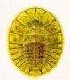  Water Penny |  | Beetle Larvae  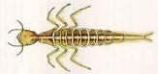 |  | Aquatic Worms 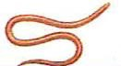
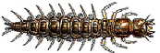  Hellgrammites |  | 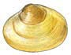  Clams |  | Blackfly Larvae 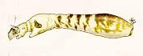
Mayfly Nymphs  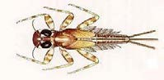 |  | Cranefly Larvae |  | 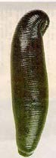  Leeches
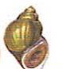  Gilled Snails |  | 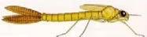  Damselfly Nymphs |  | Midge Larvae 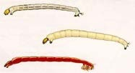
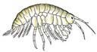
Scuds
Riffle Beetles  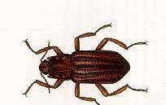 |  | 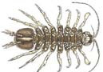  Sowbugs |  | 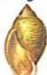  Snails
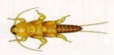  Stonefly Nymphs |  | 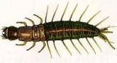  Fishflies |  | Site:
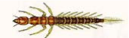
Alderflies

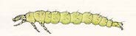  Non Net-Spinning Caddisfly Larvae |  | 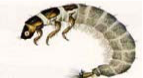  Net-Spinning  Caddisfly Larvae |  | Team Members:
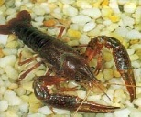
Crayfis
Total:
Total Group 1 __________  Total Group 2 __________  Total Group 3 __________  TOTAL ALL GROUPS = ___________ |  | Calculate % per Tolerance Group  % Group 1 = Total Group 1/ TOTAL ______ /_______=_________________  % Group 2 = Total Group 2/ TOTAL ______ /_______=_________________  % Group 3 = Total Group 3/ TOTAL ______ /_______=_________________
MOW the Grasse Feedback

Thank you in advance for your feedback as we continue to develop this project.

Comments on Section 1, Physical Observations:
_______________________________________________________________________
_______________________________________________________________________
_______________________________________________________________________

Comments on Section 2, Chemical Observations:
_______________________________________________________________________
_______________________________________________________________________
_______________________________________________________________________

Comments on Section 3, Biological Observations:
_______________________________________________________________________
_______________________________________________________________________
_______________________________________________________________________

Please comment on your experience following the Field Guide.
_______________________________________________________________________
_______________________________________________________________________

Did you enjoy Monitoring Our Water? Which Section did you like best? Why?
_______________________________________________________________________
_______________________________________________________________________
_______________________________________________________________________

Additional comments:
_______________________________________________________________________
_______________________________________________________________________

Thank you! Your contribution makes a difference to our project.

Contact us at info@natureupnorth.org

Appendix I: Water Assessments by Volunteer Evaluators (WAVE)

Water Assessments by Volunteer Evaluators (WAVE) is citizen-based water quality assessment developed by the NYS Department of Environmental Conservation (NYSDEC). The purpose of WAVE is to enable citizen scientists to collect biological data for assessment of water quality on wadeable streams in NY State.

Samples Collected by Citizen Scientists:

WAVE citizen scientists collect benthic macroinvertebrates from wadeable streams. Sampling can be conducted any time between July 1 and September 30. Participants collect riffle-dwelling benthic macroinvertebrates and preserve one or two example specimens of each macroinvertebrate type in a voucher collection.

Samples are identified and Interpreted by the WAVE Coordinator
The WAVE coordinator identifies all macroinvertebrates in the WAVE samples to the level of family and uses these data to calculate a water quality assessment:

More information: https://www.dec.ny.gov/chemical/92229.html

Appendix II: Sampling Kit Instructions

Instructions for CHEMets® Dissolved Oxygen Kit:

- Fill the sample cup to the 25 mL mark with the sample to be tested.
- Place the ampoule, tip first, into the sample cup. Snap the tip. The ampoule will fill, leaving a bubble for mixing.
- To mix the ampoule, invert it several times, allowing the bubble to travel from end to end.
- Dry the ampoule and wait 2 minutes for color development.
- Obtain a test result by placing the ampoule between the color standards until the best color match is found.

Instructions for LaMotte® Precision pH 3.0-10.5 Kit

- Insert Wide Range pH Octa-Slide 2 Bar into the Octa-Slide 2 Viewer.
- Fill a test tube to the 10 mL line with sample water.
- Add 10 drops of Wide Range pH Indicator.
- Cap and mix.
- Insert test tube into Octa-Slide 2 Viewer.
- Match sample color to a color standard. Record pH.

Instructions for CHEMetrics Phosphate Kit

- Fill the sample cup to the 25 mL mark with the sample to be tested.
- Add 2 drops of A-8500 Activator Solution. Cap the sample cup and shake it to mix the contents well.
- Place the CHEMet ampoule, tip first, into the sample cup. Snap the tip. The ampoule will fill leaving a bubble for mixing.
- To mix the ampoule, invert it several times, allowing the bubble to travel from end to end.
- Dry the ampoule and wait 2 minutes for color development.
- Obtain a test result using the appropriate comparator.

Instructions for LaMotte Nitrate Nitrogen Low Range Comparator Kit

- Fill the water sampling bottle with sample water.
- Slide the Nitrate-Nitrogen Low Range Comparator Bar into the Low Range Comparator Viewer.
- Fill one test tube to the 10 mL line with sample water. Place in Low Range Comparator in the rear slot.
- Fill another test tube to the lower line (5 mL) with sample water.
- Dilute to second line with Mixed Acid Reagent. Cap and mix.
- Wait 2 minutes.
- Use the 0.1 g spoon to add one level measure (avoid any excess) of Nitrate Reducing Reagent.
- The mixing procedure is extremely important. Cap tube. Invert tube slowly and completely 30 times in 1 minute to insure complete mixing.
- Wait 10 minutes.
- Insert test tube into Low Range Comparator in the front slot. Match sample color to a color standard.
        - Position the comparator so that light shines down through the test tubes. Tilt the comparator until the color standards and sample are illuminated. Match the color of the reaction to the color standards.
- Read the result from the Low Range Comparator Bar and record as ppm Nitrate-Nitrogen. NOTE: To convert to nitrate, multiply by 4.4 and record as ppm Nitrate.

Procedure for Coliscan Easygel® Water Testing Kit

- Either collect your water sample in a sterile container and transport the water back to the test site, or take a measured water sample directly from the source and place directly into the bottle of Coliscan Easygel.
NOTE: Water samples kept longer than 1 hour prior to plating, or any Coliscan Easygel bottle that has had sample placed into it for transport long than 10 minutes, should be kept on ice or in a refrigerator until plated.
- Label the petri dishes with the appropriate sample information. A permanent marker or wax pencil will work.
- Sterilely transfer 1-5 mL of water from the sample containers into the bottles of Coliscan Easygel.
- Swirl the bottles to distribute the inoculum and then pour the medium/inoculum mixtures into the correctly labeled petri dishes. Place the lids back on to the petri dishes.
- Gently swirl the poured dish until the entire dish is covered with liquid (be careful not to splash over the side or on the lid).
- The dishes may be placed right-side-up directly into a level incubator or warm level spot in the room while still liquid. Solidification will occur in approximately 90 minutes.
- Incubate at 35 degrees Celsius (95 degreed Fahrenheit) for 24 hours, or at room temperature for 48 hours.
- Inspect the dishes. Refer to Coliscan Color Guide card.
  - Count all the dark blue/purple colonies on the Coliscan dish (disregard any light blue, blue-green or white colonies), and report the results in terms of E. coli or Fecal Coliform per mL of water.
  - Count all the pink and dark blue/purple colonies on the Coliscan dish (disregard any light blue, blue-green or white colonies) and report the results in terms of total coliforms per mL of water.
NOTE: to report in terms of E. coli or Fecal Coliform per 100 mL of water, follow these 2 steps.
- Divide 100 by the number of mL that you used for your sample
- Multiply the count in your place by the result obtained from #1
Ex. For a 3 mL sample with 4 E. coli colonies: 100/3 = 33.3. So 4 E. coli colonies multiplied by 33.3 will be 133.2 E. coli per 100 mL of water. Use the same steps for a total coliform count.

